CS 255 System Design Document
6/21/26
Eric Sawyer

UML Diagrams

Use Case Diagram
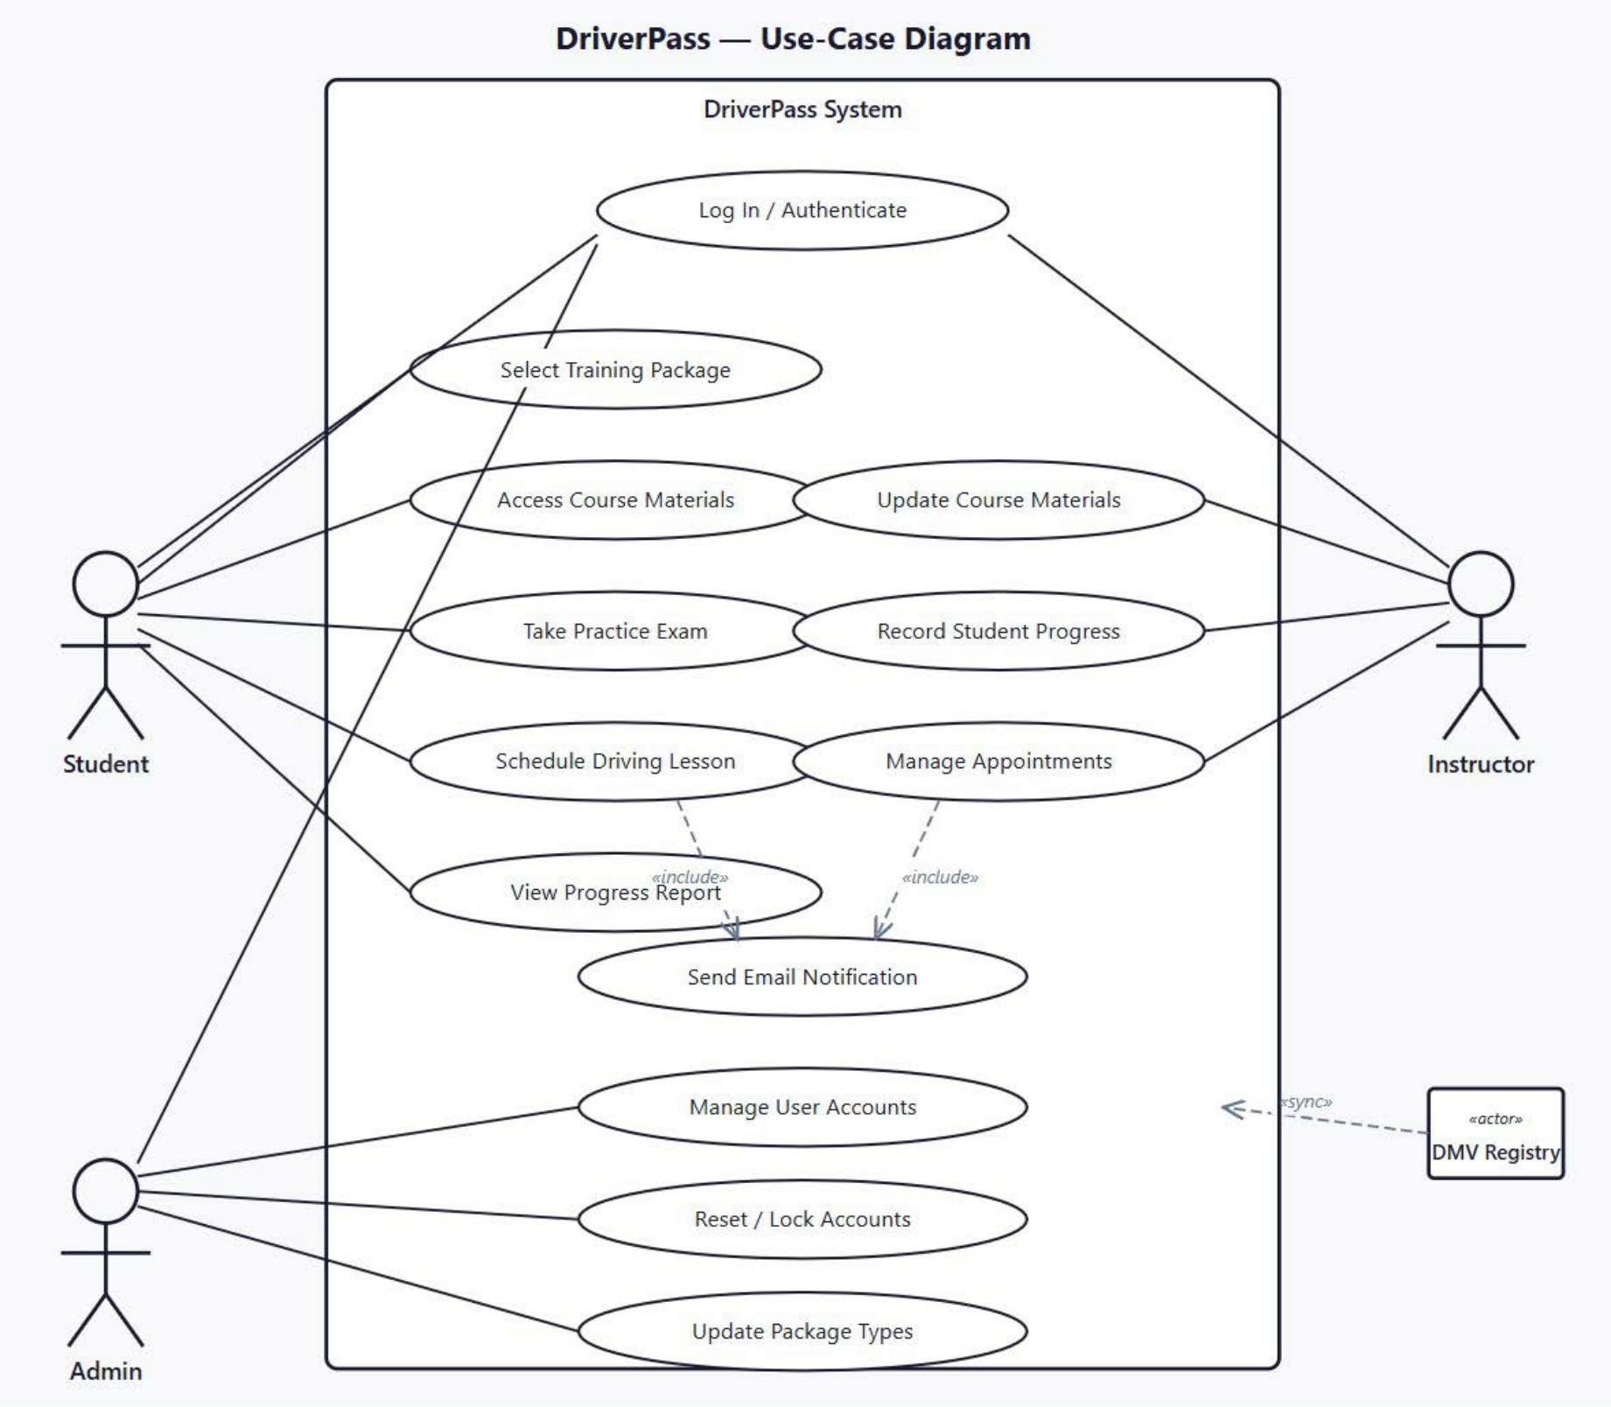

Activity Diagrams:

Use Case: User login/authentication.
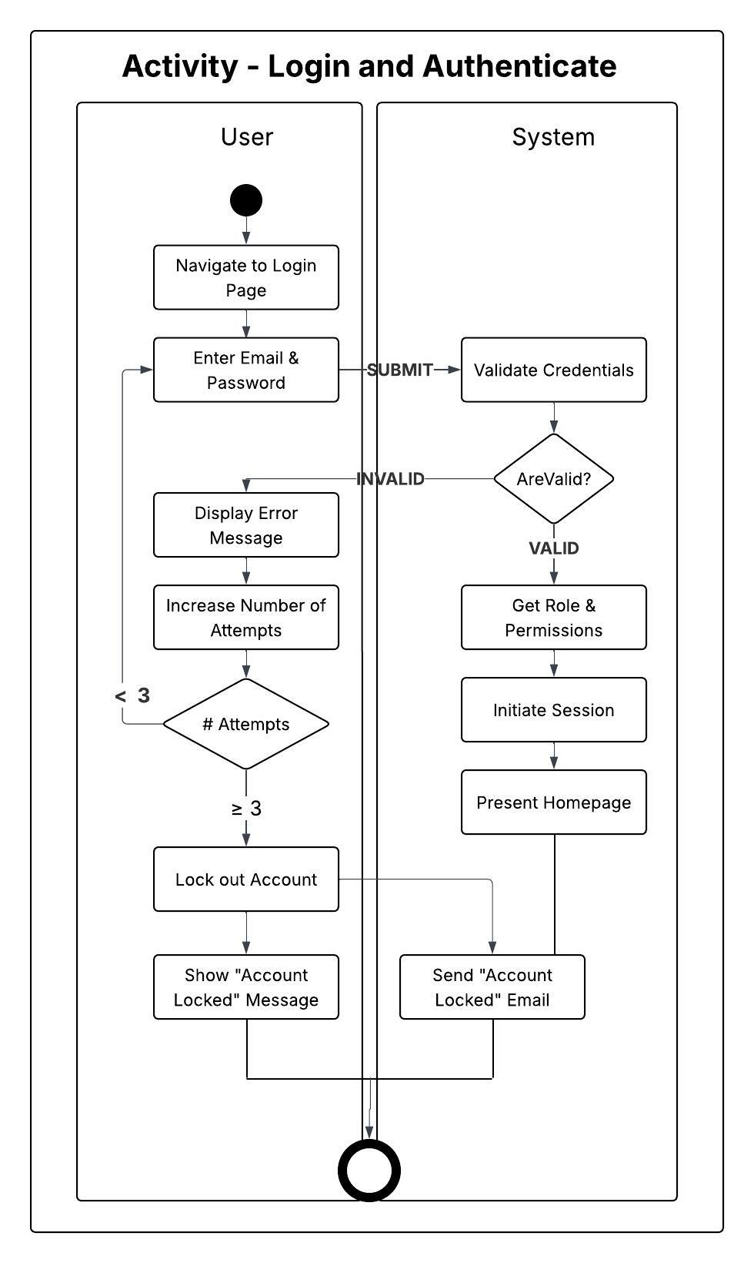

Use Case: A student scheduling a lesson.

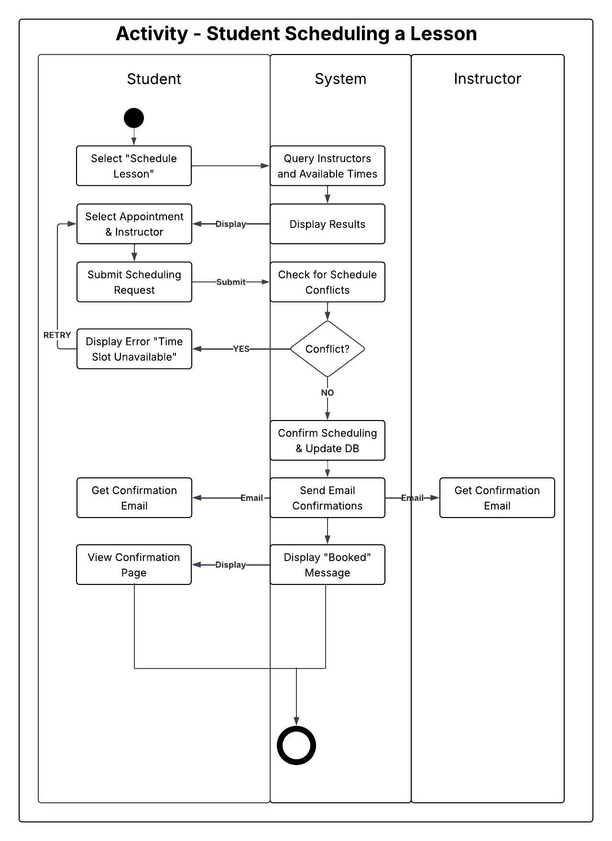

UML Sequence Diagram

Sequence: A student scheduling a lesson.
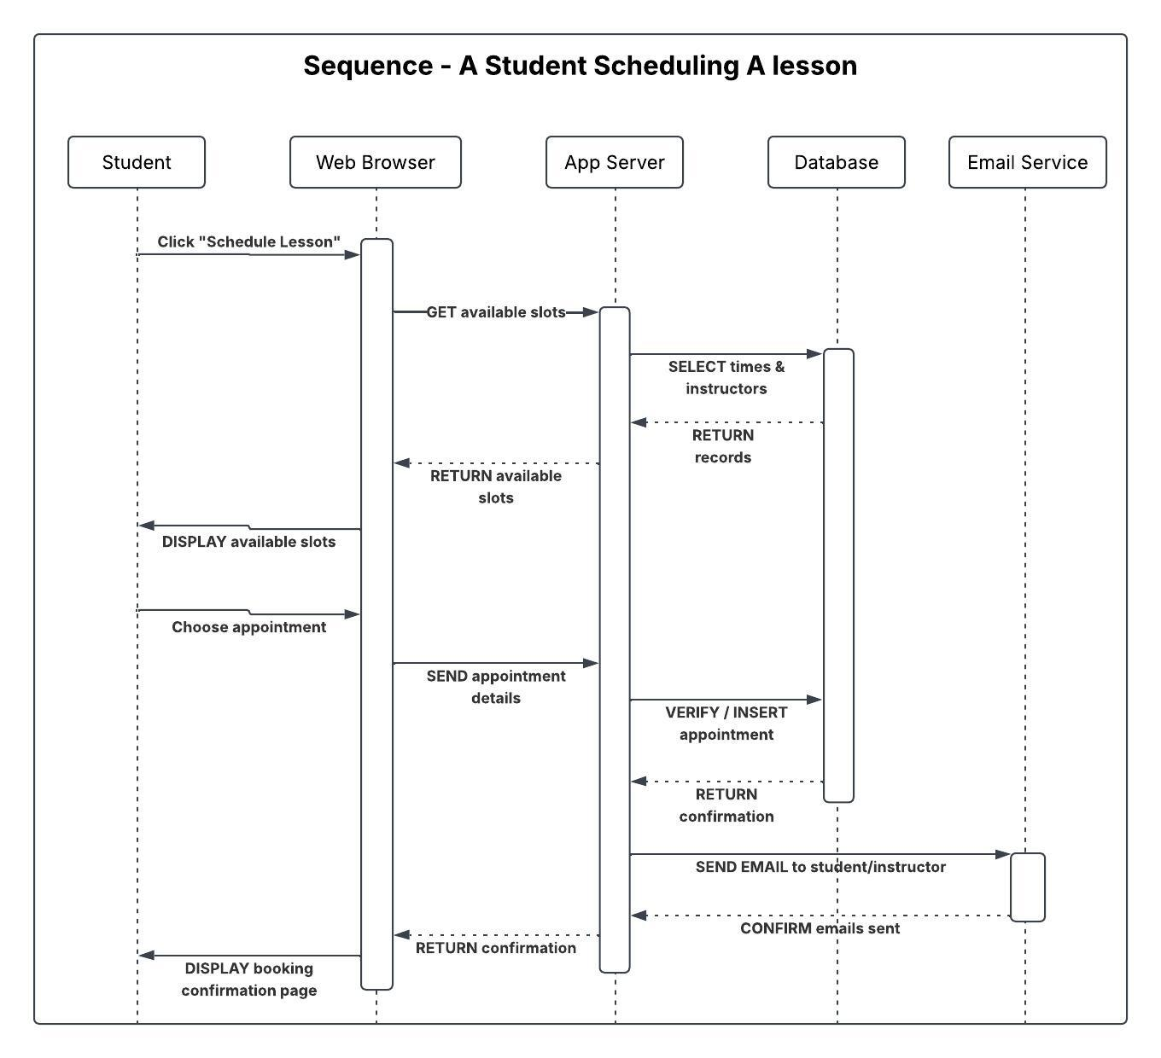

UML Class Diagram
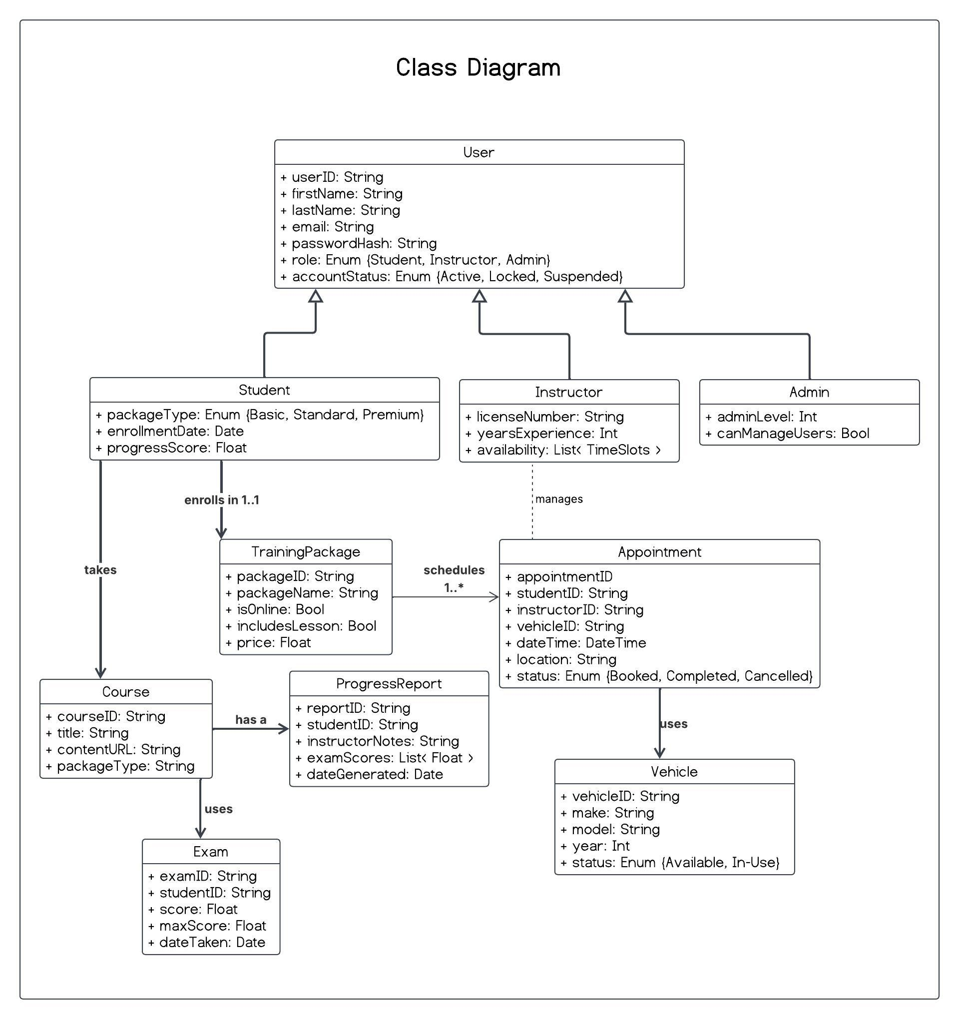

Technical Requirements

Hardware Requirements

Cloud Hosting: The application and database must be deployed on a cloud platform (e.g. AWS, Azure, or Google Cloud) with auto-scaling capabilities to ensure 24/7 uptime. A minimum of two application server instances should run behind a load balancer to eliminate single points of failure.

Database Servers: Multiple relational database instances (e.g. AWS RDS or Azure SQL) with automated backup, read replicas for performance, and failover support.

CDN / Static Assets: A content delivery network (CDN) is required to serve course materials, images, and static resources with low latency for users across different geographic regions.
Desktop / Laptop: A modern device capable of running a current web browser (Chrome, Firefox, Safari, or Edge). Minimum 4 GB RAM and a stable internet connection (≥5 Mbps).

Mobile Devices: Android (6.0+) and iOS (13+) smartphones and tablets. The web interface must adapt to screens as small as 360×640 pixels without losing of functionality.

Software Requirements

Web Application Framework: A server-side MVC framework (e.g. Node.js with Express, Django, or Spring Boot) to handle HTTP routing, business logic, and session management.

Relational Database Management System (RDBMS): A relational DBMS such as PostgreSQL or MySQL is required to manage structured data tables for Users, Appointments, Vehicles, TrainingPackages, CourseModules, PracticeExams, and ProgressReports as defined in the class diagram.

Authentication Library: An industry-standard authentication library supporting bcrypt password hashing, JSON Web Tokens (JWT) for session management, and configurable account lockout after repeated failed login attempts.

Email Service Integration: A transactional email API (e.g. SendGrid, Mailgun, or AWS SES) to dispatch automated notifications for appointment confirmation, cancellation, and account lockout events.

DMV API Webhook Client: A webhook or REST client module to synchronize driver eligibility and test result data from the State DMV registry in real time, consistent with the «sync» relationship in the use case diagram.

Responsive Web Framework: A frontend framework (e.g. React, Vue, or Angular) with a CSS grid/flexbox layout system to deliver a consistent, role-aware interface across desktop and mobile browsers.

Browser Compatibility: The application must be compatible with the two most recent versions of Chrome, Firefox, Safari, and Edge.

Interactive Exam Engine: A client-side quiz/exam module that presents practice questions, accepts user responses, and returns automated grading feedback immediately upon submissions.

Tooling and Infrastructure

Version Control: All source code must be managed in a Git repository (e.g. GitHub or GitLab) with branch-based development workflows and code reviewing requirements before merging with production.

CI/CD Pipeline: A continuous integration/continuous deployment pipeline (e.g. GitHub Actions, Jenkins, or CircleCI) must run automated tests and dependency validation after every update, satisfying the adaptability requirement from the business requirements document.

Monitoring & Logging: Application and server logs must be aggregated in a centralized logging service (e.g. AWS CloudWatch, Datadog, or ELK Stack). Automated alerts must notify administrators of downtime, error rate spikes, or brute-force login patterns.

Database Backup & Recovery: Automated daily database backups with a minimum 30-day retention policy and tested restore procedures to protect against data loss.

Scheduling Module: A backend scheduling engine that enforces valid time blocks, prevents double-booking of instructors and vehicles, and supports calendar-based queries by date, instructor, and location.

